Name =

Abubaker Attique

Roll no =

P20-0560

Section =

5-A

**1.Setting Router Modes on 2600 Series Routers**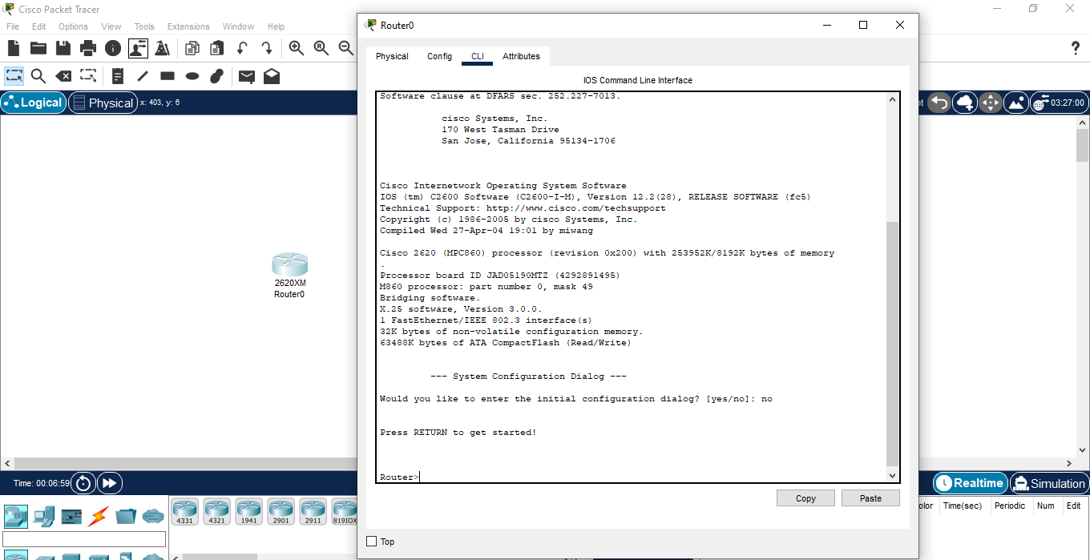

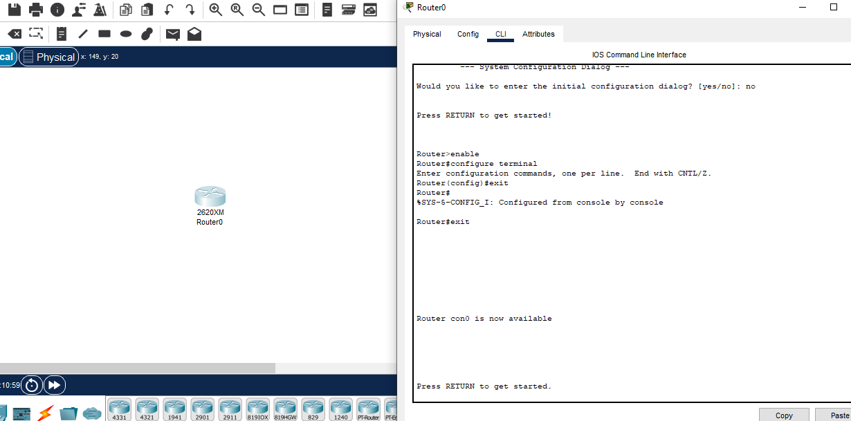

**2. Changing Hostname of the Router**

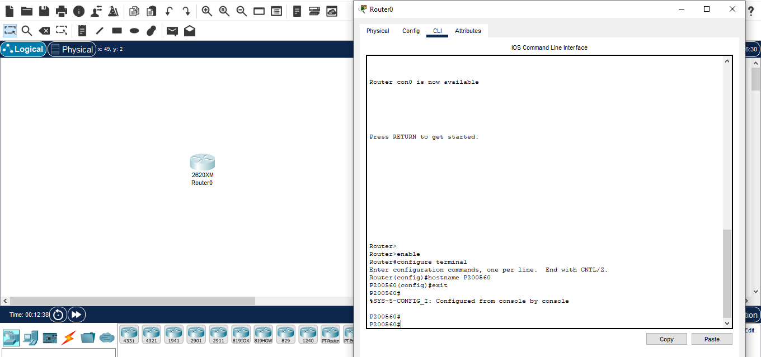

**3. Configuring Date and Time on the Router (Clock Set Command)**

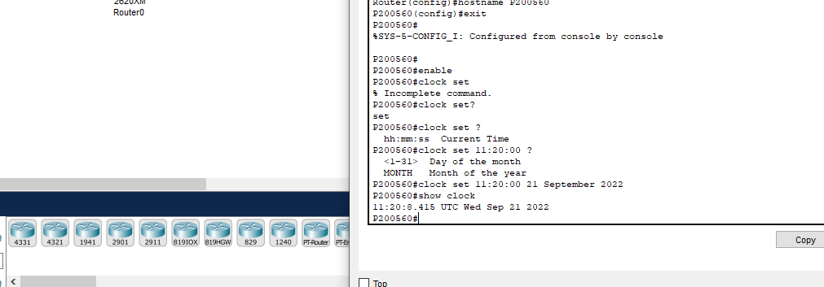

**4. Setting a banner on the Router**

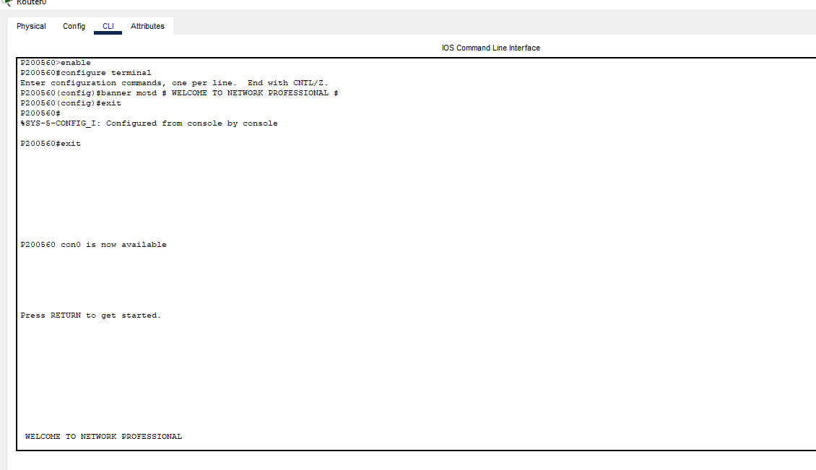

**5. Displaying the Router’s Running-Configuration and Start-Up Configuration**

P200560>enable

P200560#show running-config

Building configuration...

Current configuration : 457 bytes

!

version 12.2

no service timestamps log datetime msec

no service timestamps debug datetime msec

no service password-encryption

!

hostname P200560

!

!

!

!

!

!

!

!

ip cef

no ipv6 cef

!

!

!

!

!

!

!

!

!

!

!

!

!

!

!

!

!

!

interface FastEthernet0/0

no ip address

duplex auto

speed auto

shutdown

!

ip classless

!

ip flow-export version 9

!

!

!

banner motd ^C WELCOME TO NETWORK PROFESSIONAL ^C

!

!

!

!

!

line con 0

!

line aux 0

!

line vty 0 4

login

!

!

!

End

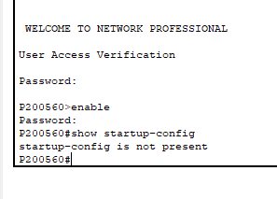

**6. Enable Password and Enable Secret Password with the Encryption Techniques/Levels**

Password For Privileged Mode

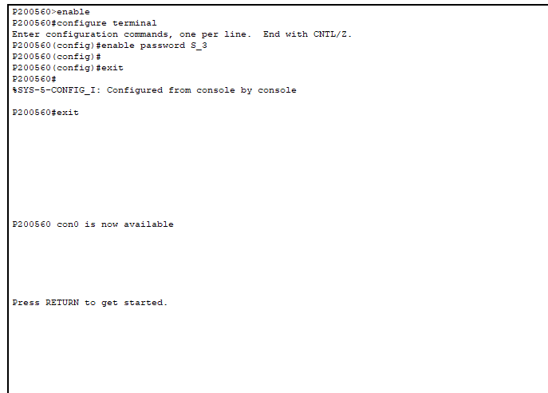

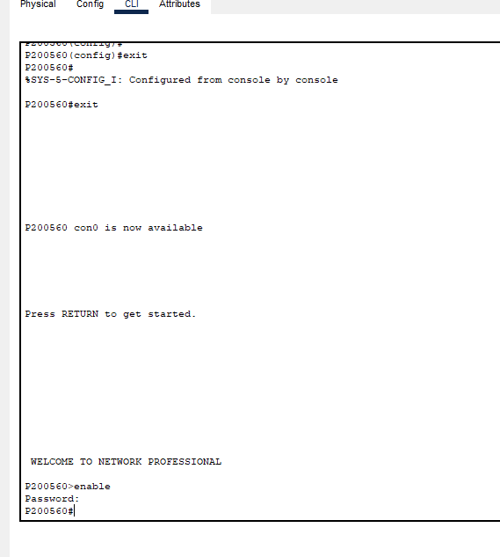

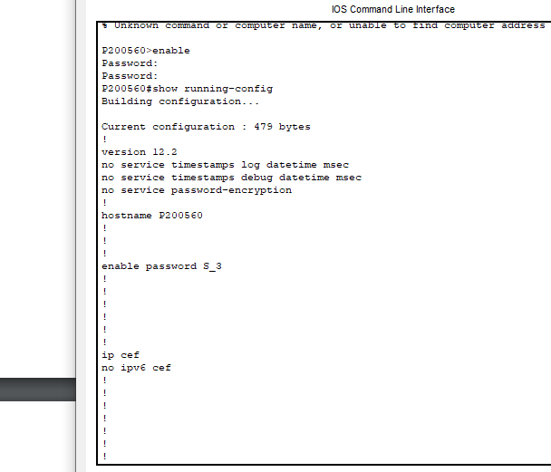

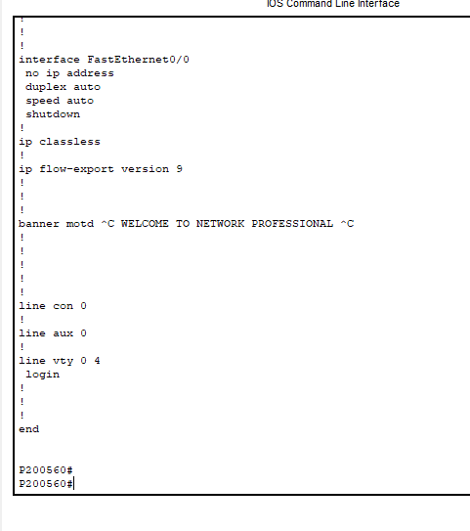

**7. Line Console Password Implementation on CISCO 2600 Series Router**

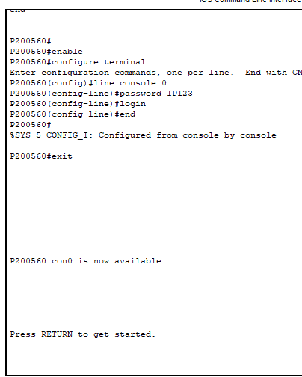

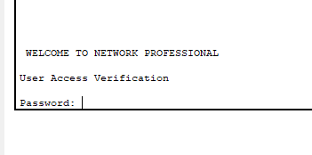

8. **What is Telnet? How to Telnet? + Line VTY/Telnet Password**

Telnet is a network protocol used to virtually access a computer and to provide a two-way, collaborative and text-based communication channel between two machines. It follows a user command Transmission Control Protocol/Internet Protocol (TCP/IP) networking protocol for creating remote sessions. Telnet is a text-based program that lets you access the console on a router or other device and issue commands. You can Telnet into a router using the Telnet client included with Windows.Unlike other protocols, Telnet isn't secure and shouldn't be used over the Internet.

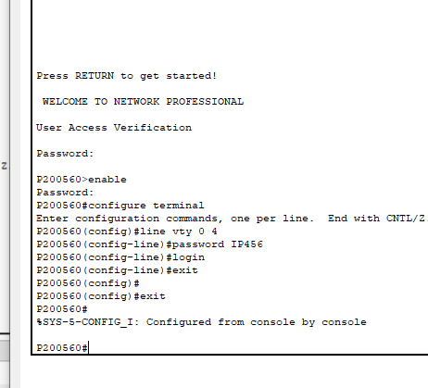

**9. Usage of Router with different topology**.

1. Star topology for wireless networks

2. P2P Topology.

3. Bus Topology.

4. Ring Topology.

5. Tree Topology.

6. Mesh Topology.

7. Hybrid Topology.

